Software Requirements Specification for project «Home plants»

April, 24 2015.

Rostov-on-Don, 2016
Table of Contents
Technical requirements 4
Data 5
Interface 6
Screen 0 – Splash 7
Screen 1 – Main menu 8
Screen 2 – Plant list 9
Screen 3 – Plant filter 13
Screen 4 – Plant description 14
Screen 5 – Information 16
Screen 6 – Rate dialog 17
Tablets – Plant list and plant description 20
Tablets – Plant filter 23
Tablets – Information 25

Technical requirements
Application will be developed for iOS v8.х, v9.x and Android v4.3+. Orientation changes will be supported on tablets only.
Supported iOS devices:
- iPhone 4, iPhone 4GS, iPhone 5, iPhone 5C, iPhone 5S, iPhone 6, iPhone 6+;
- iPad 2, iPad 3, iPad 4, iPad Air, iPad Air 2, iPad Mini, iPad Mini 2, iPad Mini 3.
For Android application will be tested on the most popular devices which guaranties operability on most devices in sale at the moment.

Data
All data will be incorporated within application. Application is intended to work offline (with the exception of secondary functionality – rate in App Store, developer feedback, etc).
Data about plants will initially be created in XML format. XML file will later be converted to SQLite database for use in application. SQLite database will also be used for favorites functionality. To add / change data after application is submitted to App Store / Google Play, application should be rebuilt and resubmitted.

Interface
Application will look and function in similar way on both platforms (iOS и Android). However both platforms provide its own requirements and recommendations to user interface (User Interface Guidelines), which will be taken into account on all phases of development process.
Interface for smartphones and tablets will differ. In the first part of the document interface for smartphones will be described, in the second part – for tablets. Tablets, unlike smartphones, may show several view controllers (screens) at once due to larger space. However fundamental functional elements will be the same on smartphones and tablets. Because of this only differences between smartphones and tablets will be described for tablets part of the document.

Screen 0 – Splash
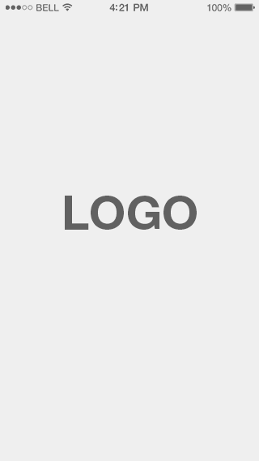
Splash will be introduced upon application launch. Splash duration is managed by OS.

Screen 1 – Main menu
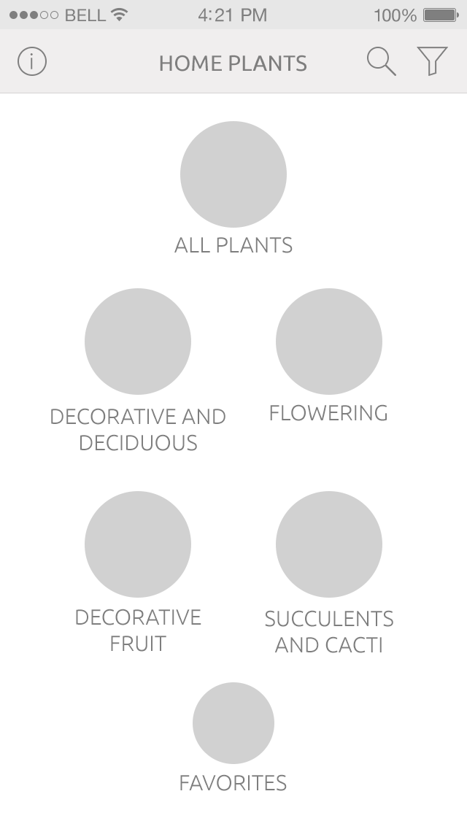
On the main menu screen there are 4 plant categories and buttons to show list of all plants and favorite plants. On tap Screen 2 – Plant list is shown, which lists plants depending on the button pressed – all plants, selected category, plants marked by the user as favorites.
On the left side of navigation bar there is Info button. On tap Screen 5 – App info is shown.
On the right side of navigation bar there are buttons for Search and Filter.
If Search button is tapped Screen 2 – Plant list is shown with active search field.
If Filter button is tapped Screen 3 – Plant filter is shown.
It is important to notice that all user choises with the exception of Info button lead user to Screen 2 – Plant list. This provides intuitive user experience.

Screen 2 – Plant list
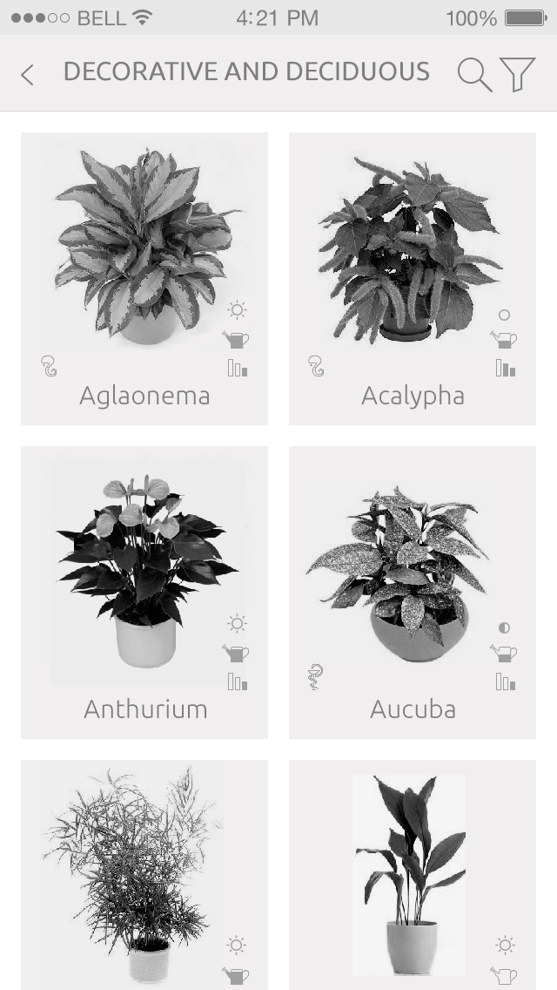
On the left side of navigation bar there is button Back, which navigates user to Screen 1 – Main menu.
In the central part of navigation bar there is category name or text «All plants» or «Favorites», depending in user choice on Screen 1 – Main menu.
In the right part of navigation bar there are buttons Search and Filter which work similar to the ones on Screen 1, with one exception – the user stays on the same screen. Both buttons actually filter current list content. Search – by containing text in plant name or plant synonyms, filter – by more complex criteria (see Screen 3 – Plant filter).
In the main part of the screen there is plant list which content is dependant on selected category.
Each list element contains plant photo, name and trait icons.
To the left of the plant image there are icons of base traits: lightening, humidity, complexity. They are required.
To the right of the plant image there are icons of additional traits, for example poisonous or healing. They are optional.
Selecting list element navigates user to Screen 4 – Plant description.
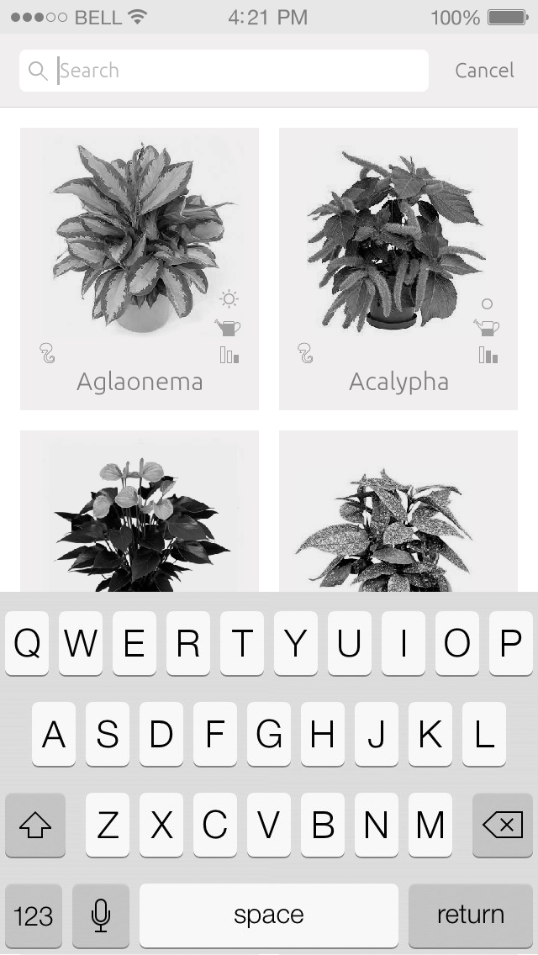
If Search button is tapped all navigation bar elements are replacing with search field with Cancel button, search field becomes active and keyboard appears from the bottom of the screen.
If Cancel button is tapped, navigation bar transforms to its initial state.
On this mockups one can see different icons layout. Final icons layout will be determined on design / development / testing phases.
Search results are changing in real time according to user input.
If no plant is found for the current search and filter criteria, image and text «Nothing was found» are displayed.
If the screen is in the favorites mode and favorites are empty, image and text «Favorites empty» are displayed.

Screen 3 – Plant filter
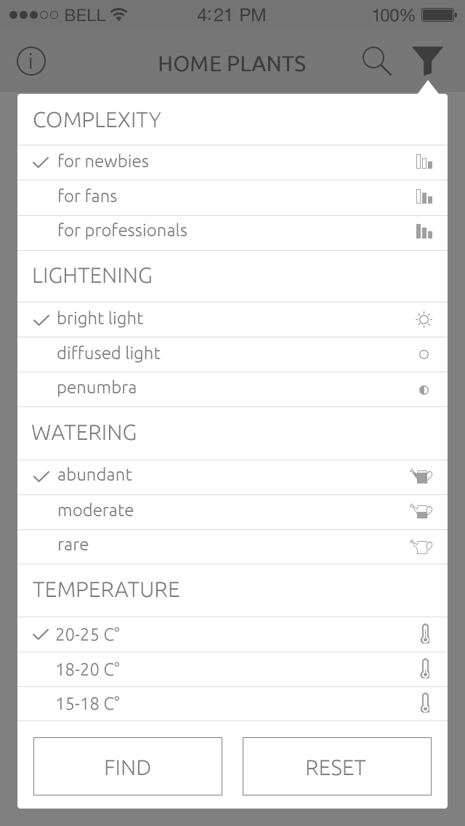
Filter contains fundamental plant parameters with values. User can select several values for each parameter. Each parameter value has text and icon. Same icons are used on Screen 2 to display plant features.
Filter rules:
- If no value is selected for parameter, it is ignored.
- If one or more values are selected for parameter, they are used to filter plants.
Such rules are intuitive – if the user doesn't care about any parameter, he just don't touch it.
If Find is tapped the dialog disappears. If the user was on Screen 1, he is navigated to Screen 2 with filtering. If the user was on Screen 2, plant list filters according to selected category.
If Reset is tapped, all selected values become deselected.
To close dialog user should tap outside dialog or Filter button again.

Screen 4 – Plant description
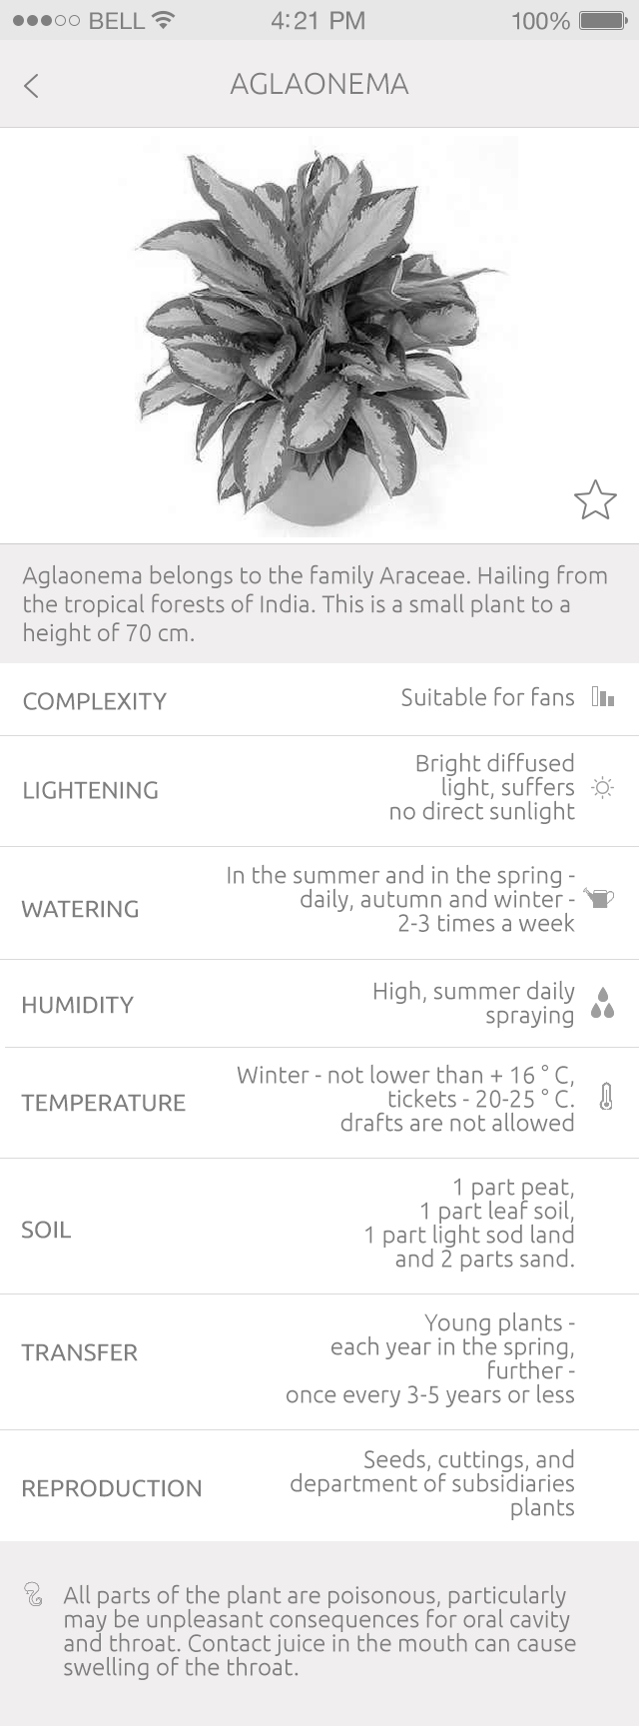
Plant description screen is the center of the application. It contains a lot of information. On design phase of the project screen structure and its elements should be thoroughly thought taking into account:
- Plant information must be complete. The user shouldn't have the desire to check for additional information somewhere else.
- Information should follow from the most important to the least important.
- Information should be presented in such way for the user to be able to find all important information in 1-2 seconds, but not research through the whole article for 30 seconds or more.
Navigation bar contains plant name and Back button.
Below navigation bar there is plant photo and Add to Favorites / Remove from Favorites button.
Below there is short plant description.
Below structured plant information follows for parameters:
- complexity
- lightening
- watering
- humidity
- temperature
- soil
- transfer
- reproduction
Parameter list could be changed on design phase to make the information representation more convenient.
In the bottom of the screen there is information which is interesting, but not very important for everyday use. For example if the plant is poisonous or healing.

Screen 5 – Information
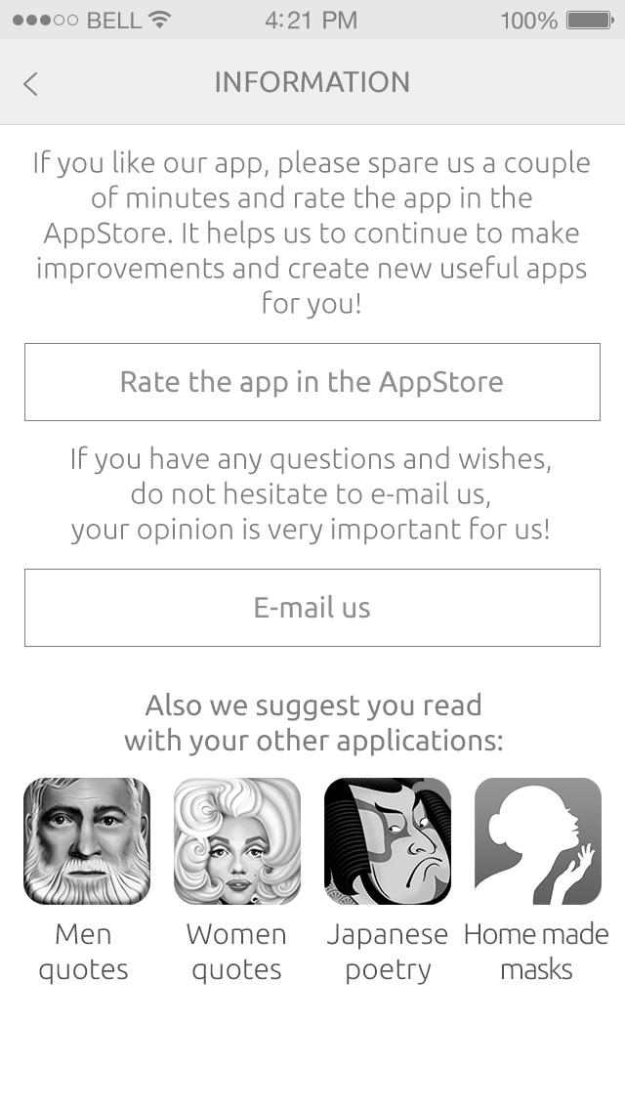
On information screen the user can:
- Navigate to App Store to rate application.
- Write e-mail to developers.
- Download other applications, developed in Iron Water Studio.
On Rate the app in App Store button tap the user will be navigated to Write Review screen in App Store application.
On E-mail us button tap the user will be presented system «Write e-mail» screen with pre-filled fields:
- To – info@ironwaterstudio.com
- Subject – Feedback from Home Plants application
On one of other application buttons tap the user will be navigated to corresponding screen in App Store to download application.

Screen 6 – Rate dialog
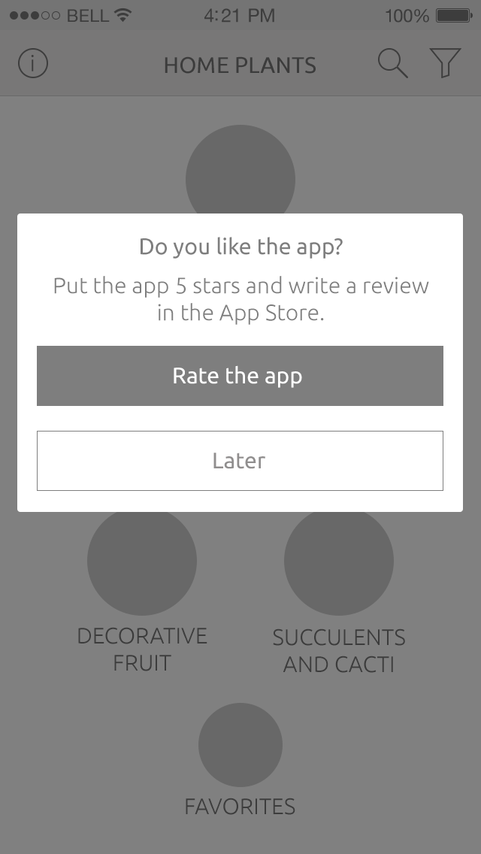
Every 10 launches the user will be presented a dialog offering to rate application in App Store.
On Rate the app button tap the user will be navigated to Write Review screen in App Store application. Rate dialog will not be shown again in the future.
On Later button tap dialog screen disappears and will be shown again after 10 application launches.
Tablets – Main menu
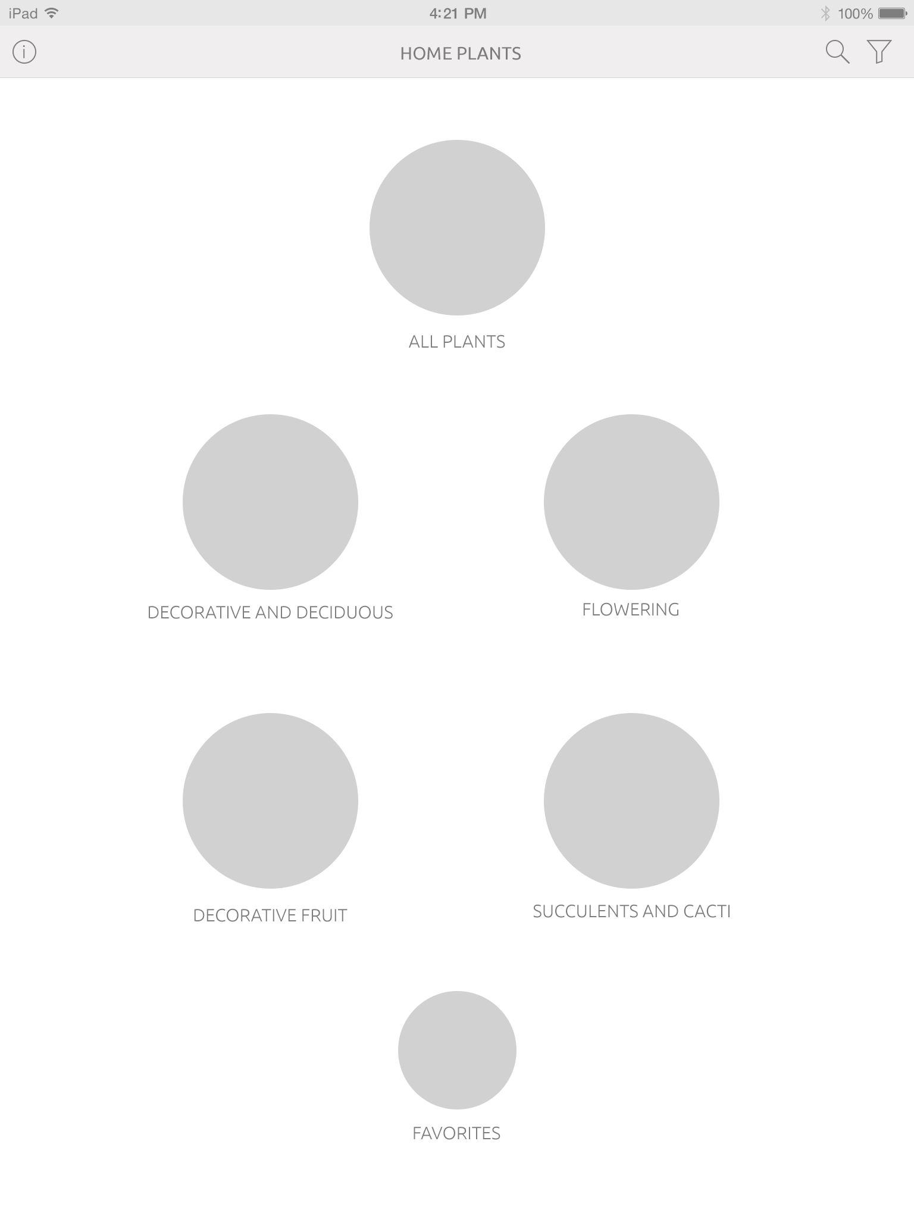
Main menu screen is very similar to the one for smartphones. Only size and location of elements differs.
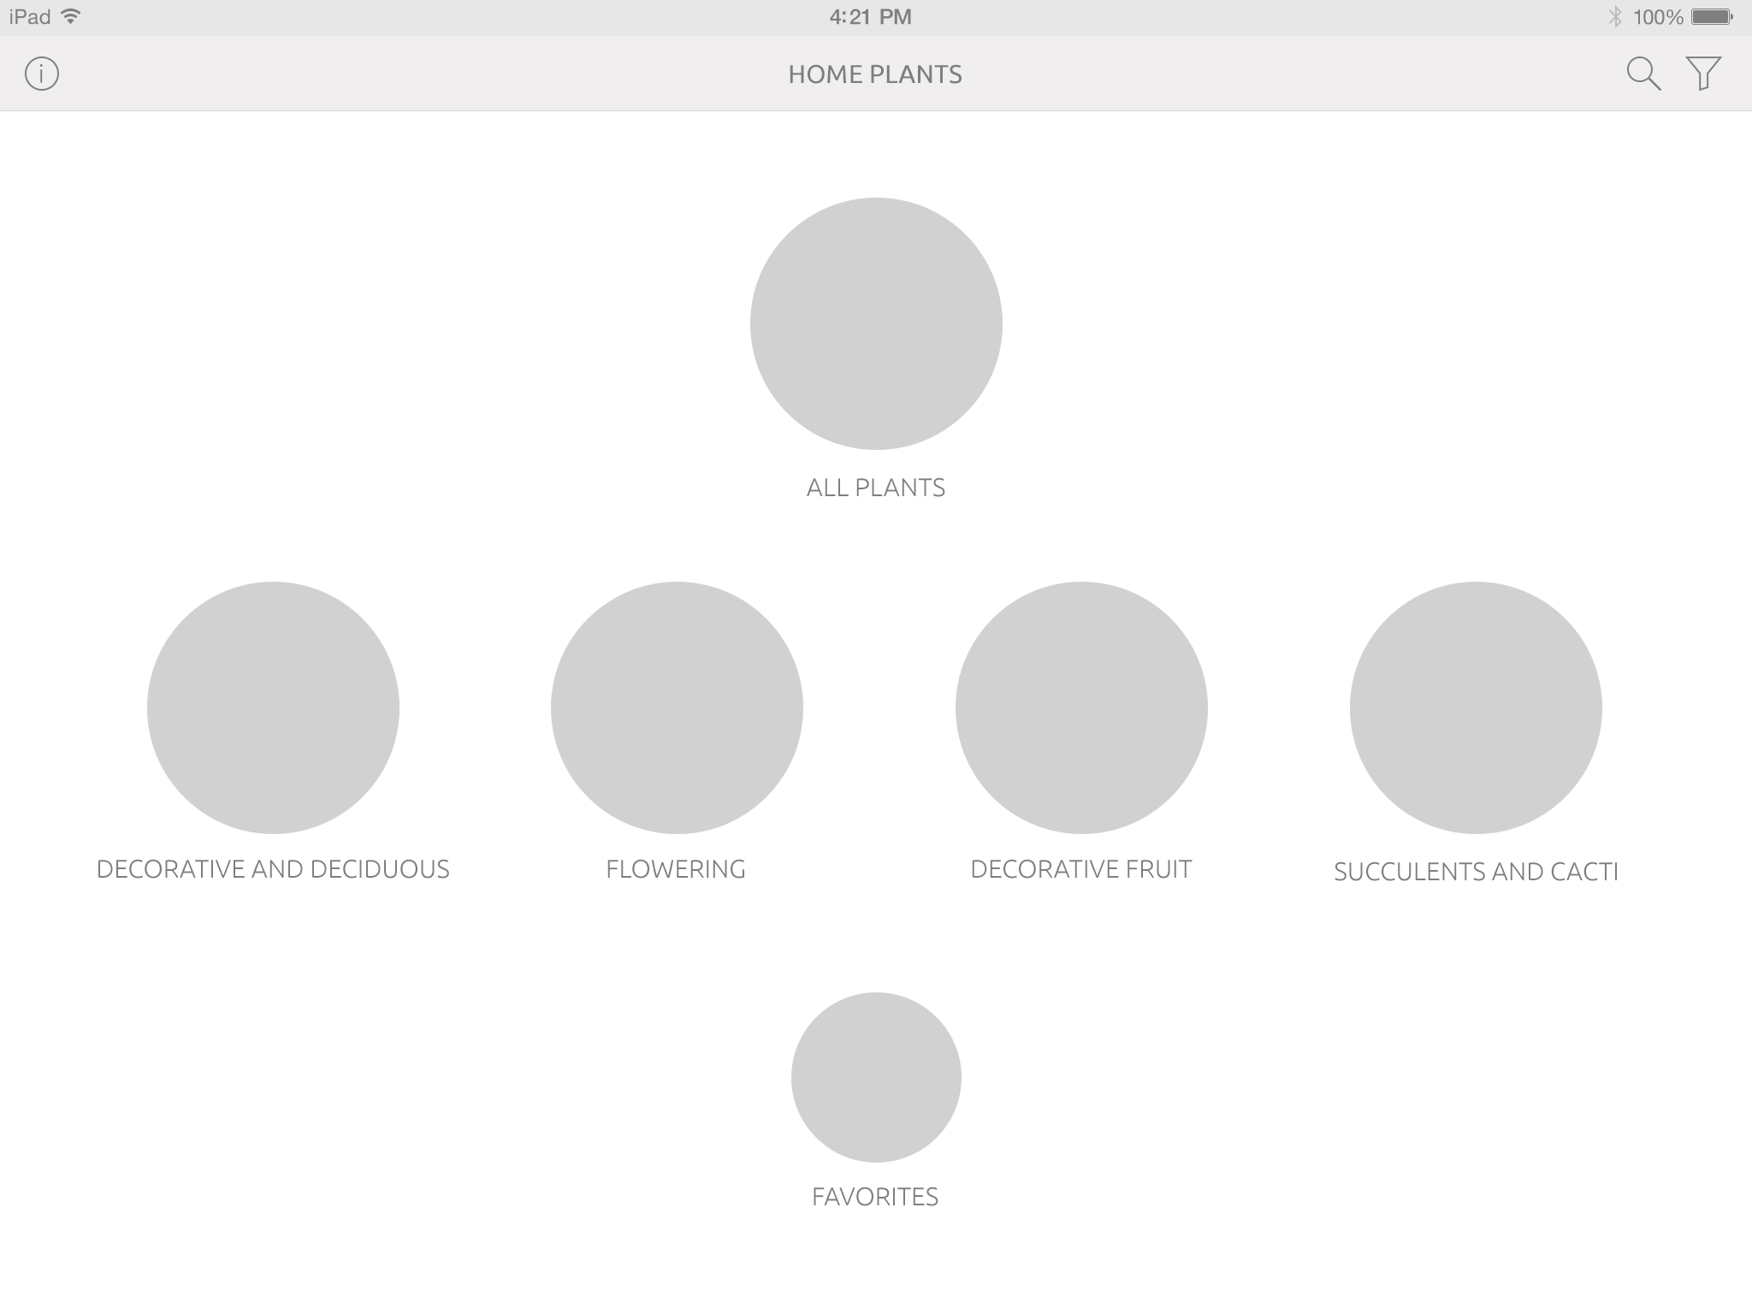
This mockup shows preliminary location of elements in landscape orientation. Can be changed on design phase.

Tablets – Plant list and plant description
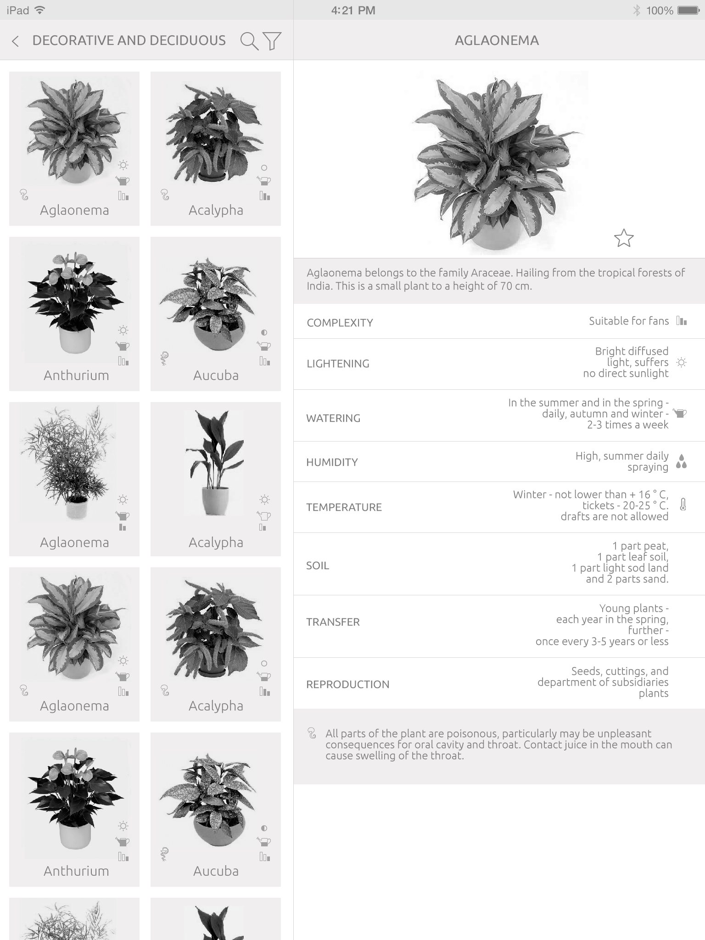
On tablets plant list and plant description screens will be united. Plant list is on the left side and plant description is on the right. On plant selection on the left, plant description on the right will be changing. Selected plant in the list will be marked with colour or frame. There are 2 plants in a row as on smartphones.

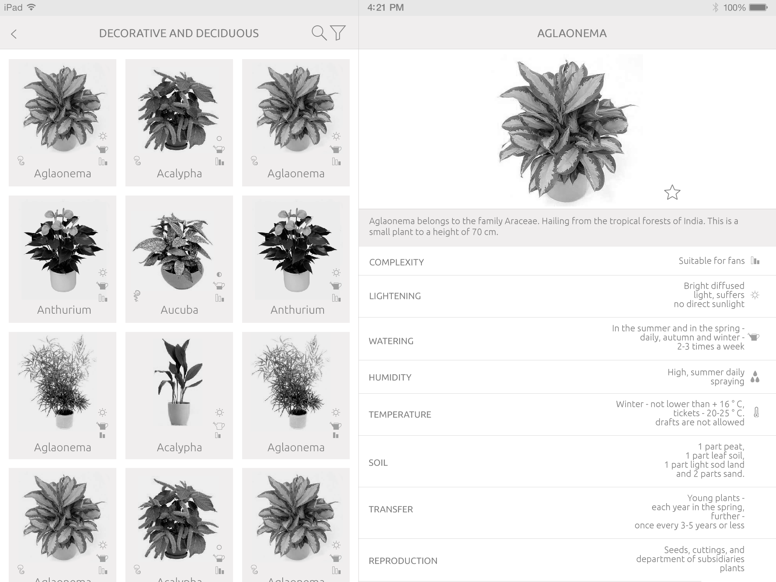
In landscape orientation plant list will contain 3 plants in a row.

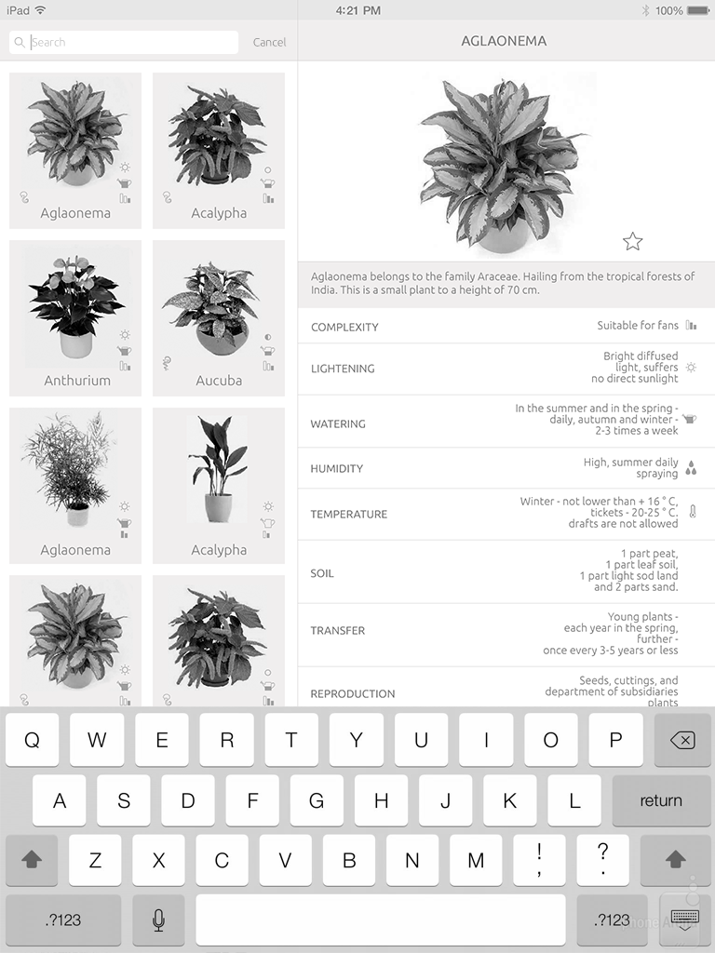
This is how the screen will look like when search is activated.

Tablets – Plant filter
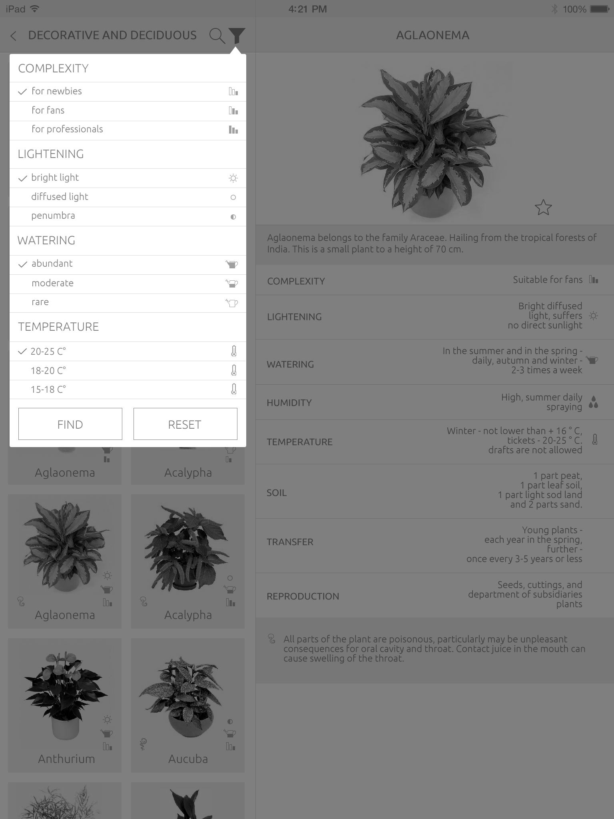
Plant filter is shown on the top of plant list, as on smartphones.

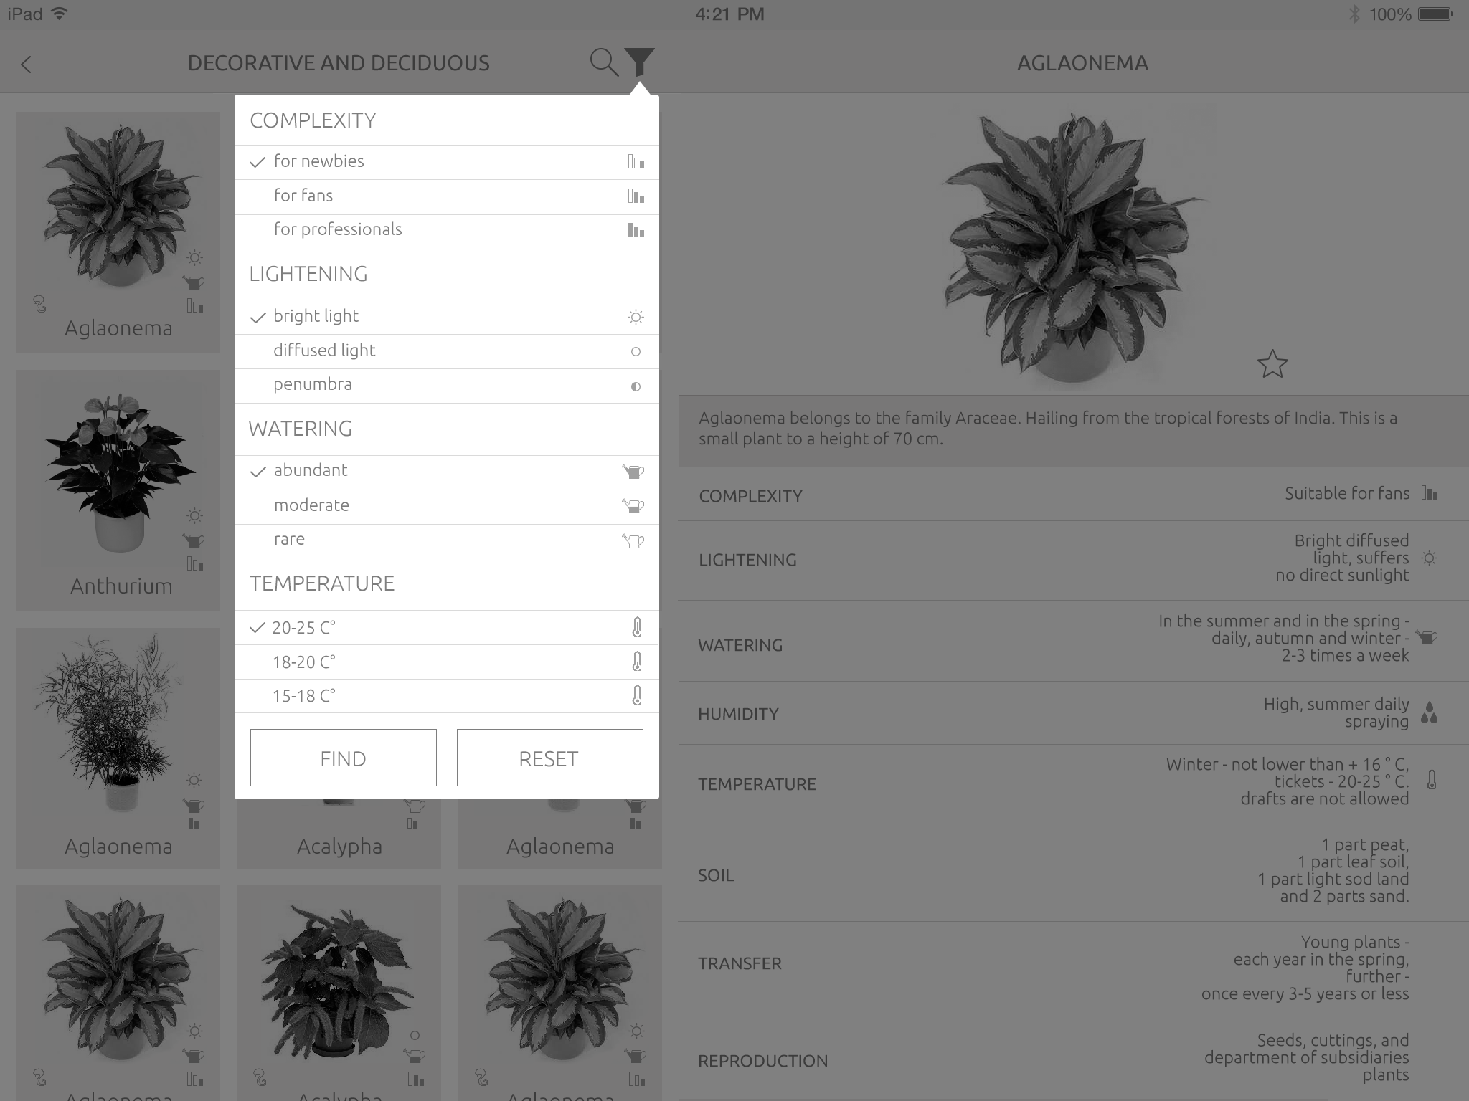
The same in landscape orientation.

Tablets – Information
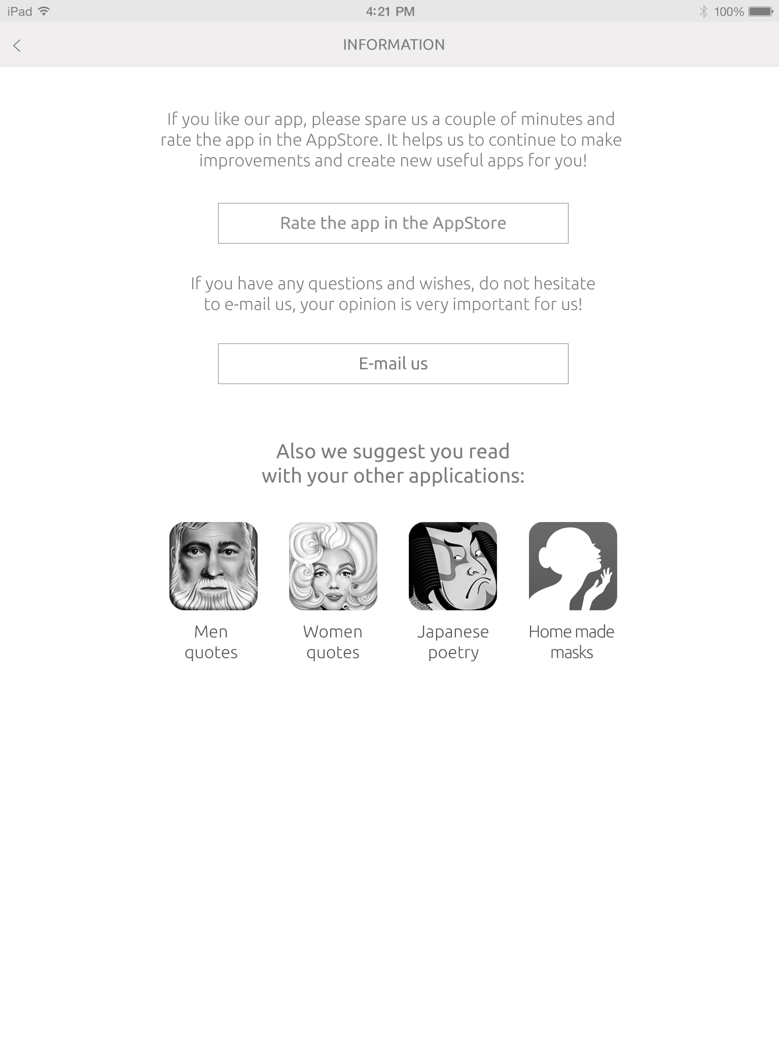
Similar to smartphones.

WHAT’S NEXT: the app is completed, see design and a link to download here: http://www.ironwaterstudio.com/en/project/homeplants

